SITE VISUAL DOCUMENTATION
The following pictures in figs. 1-7 were some of the visuals and pieces of evidence captured during the JIV showing the spill point and the impacted areas. (See pictures below)
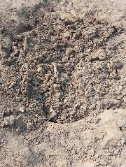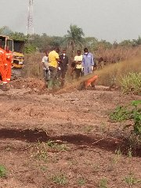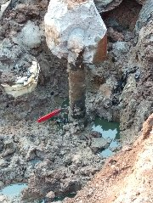
Fig.3: Exposed point showing 3’’ ball valve with nipple installed on NAOC facility (pipeline).
Fig.2: Crude oil gushing out of the spill point during manual excavation
Fig.1: Identified spill point from previous excavation

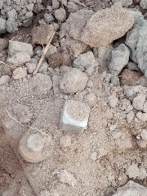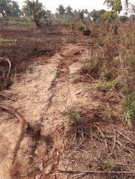
Fig.5: The path showing the connecting pipe on NAOC facility over a stretch of 300m. The area is slightly impacted.
Fig.4: 2’’ control valve on the pipe connected to the 3’’ ball valve installed on NAOC facility. The distance between both ends is 5m.

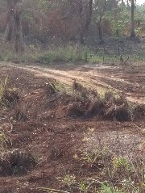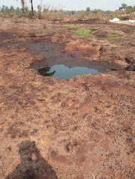
Fig.7: showing heavily impacted area with free phase oil within.
Fig.6: showing slightly impacted area

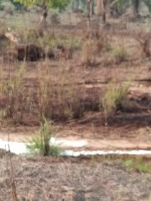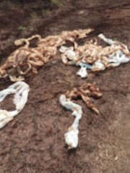
Fig.9: Disused booms seen at the spill site and the area are heavily impacted by spill.

Fig.8: showing another area that is slightly impacted by spill.

